Core Documentation

This is the official Core X documentation.

What is Core X, exactly ?

"Core X is the latest version, **completely redesigned**, of *Core* (now referred to as Core LEGACY). This version is designed to be *simpler*, *faster*, and *lighter.*"

Core X adds a ton of *new features*, like the ***Input System***, the *Macro Tool*, *Toggle Mode*, with a *built-in CPS calculator*.

Oh, and there’s frequent updates.

Let’s get into it !

First, let’s take a look at the *UI*.

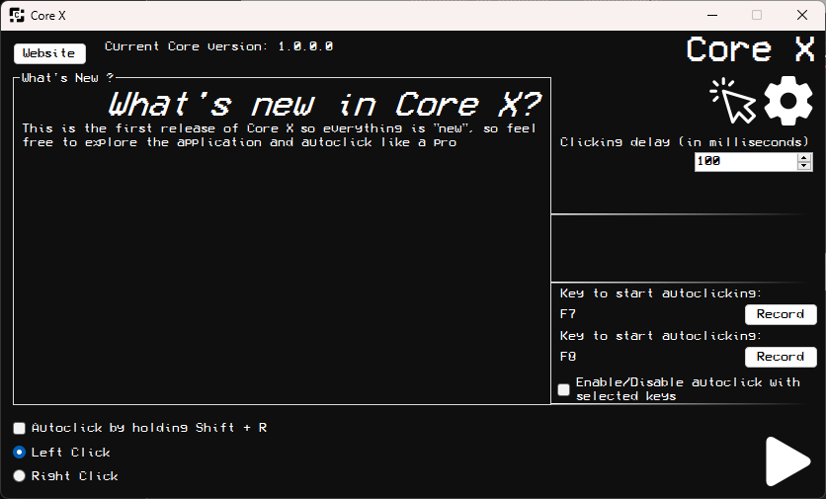

It’s pretty simple, every control will be explained.  
Please notice that the documentation is actually made for the 1.0.0 though the documentation will be updated soon after the app updates.

Clicking Delay

Key Selection System

Clicking Delay

Patch Notes

Useful Information

Settings

CPS Counter

Key Hold System (Shift + R)

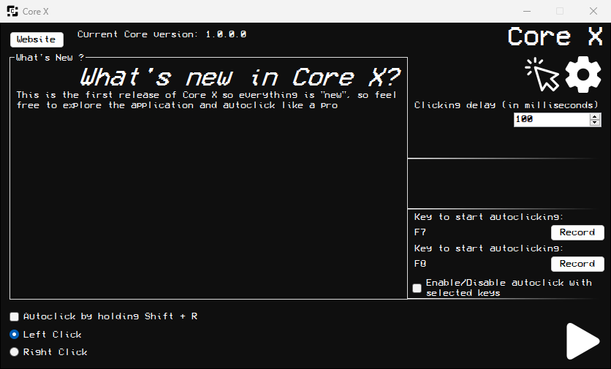

A click delay in an autoclicker refers to the amount of time the autoclicker waits between each simulated mouse click.

The click delay can be adjusted by the user to control the speed and frequency of the clicks. For example, a shorter delay will result in faster clicking, while a longer delay will slow down the clicking rate. Adjusting the click delay allows users to fine-tune the autoclicker's behavior to suit their needs, whether it's for gaming, automation tasks, or other purposes.

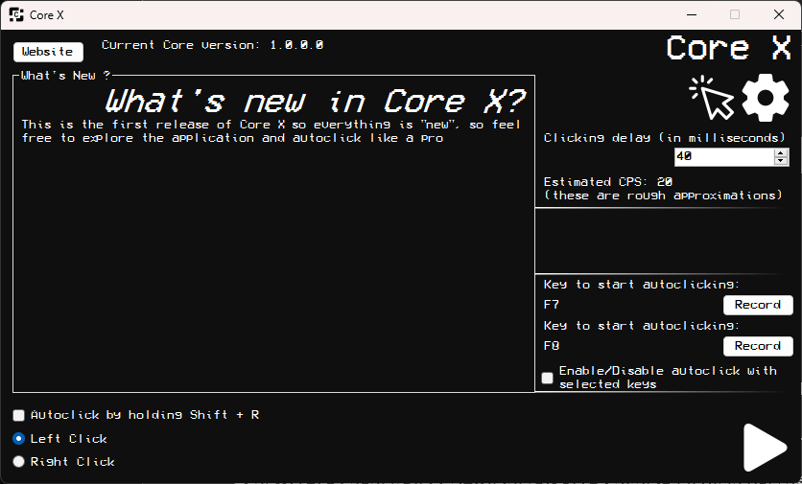

The real-time click per second (CPS) counter in Core X measures the average number of mouse clicks registered per second over a given period. It provides immediate feedback on the clicking speed of the autoclicker, allowing users to monitor and adjust the click delay accordingly to achieve their desired clicking rate. This counter is valuable for users who require precise control over their autoclicker's performance, such as gamers aiming for optimal performance in click-intensive games or individuals automating repetitive tasks that require a specific click frequency.

Please note that RTCPS is not yet fully operational.

Input System (Key Selection System)

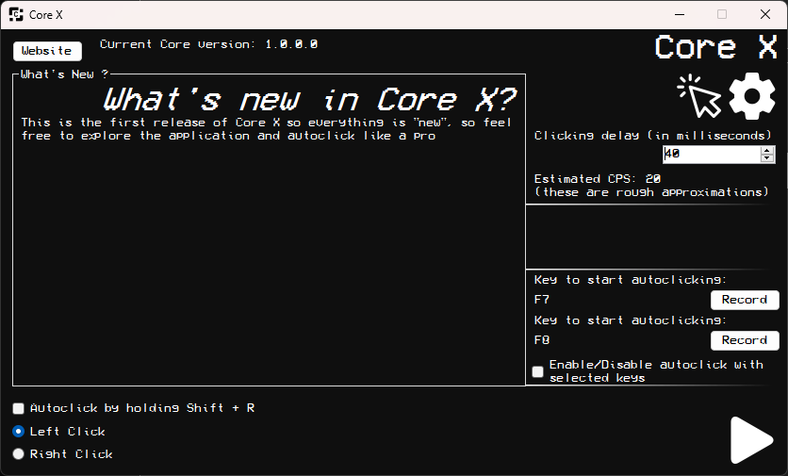

The Key selection system is a feature within the autoclicker program that enables users to bind a specific keyboard key to toggle the autoclicker's functionality on and off. This feature enhances user control and convenience by allowing them to activate or deactivate the autoclicker instantly with a single key press, without the need to navigate through menus or manually start and stop the program. By assigning a key of their choice, users can seamlessly integrate the autoclicker into their workflow or gaming experience, enabling precise control over when the autoclicker operates, thereby enhancing efficiency and usability.

You have to check « Enable/Disable autoclick with selected keys » for it to work.

Key Hold System

The key hold system is a functionality within the autoclicker program that activates the autoclicker when the user holds down a specific combination of two keys : Shift + R, and automatically deactivates it when the keys are released. This feature offers a hands-free way for users to control the autoclicker's operation.

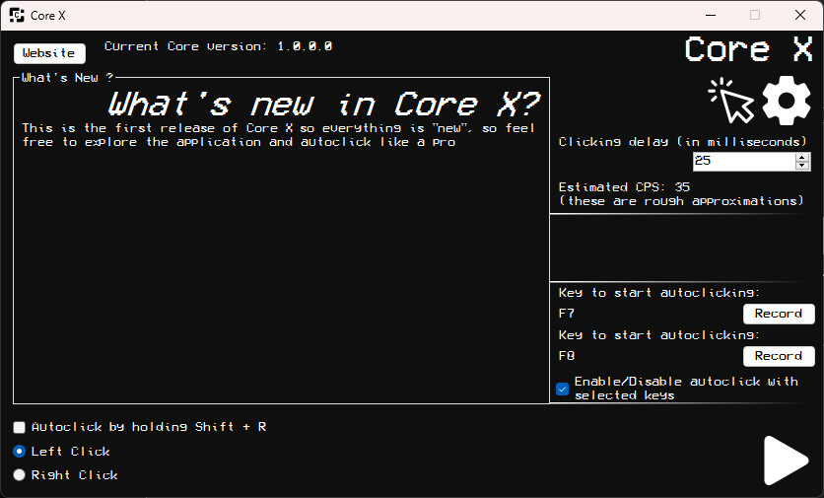

When this box is checked, you just have to press Shift and R and the autoclicker will activate.

CPS Calculator

The CPS calculator feature is very useful for users that want precise CPS approximation. 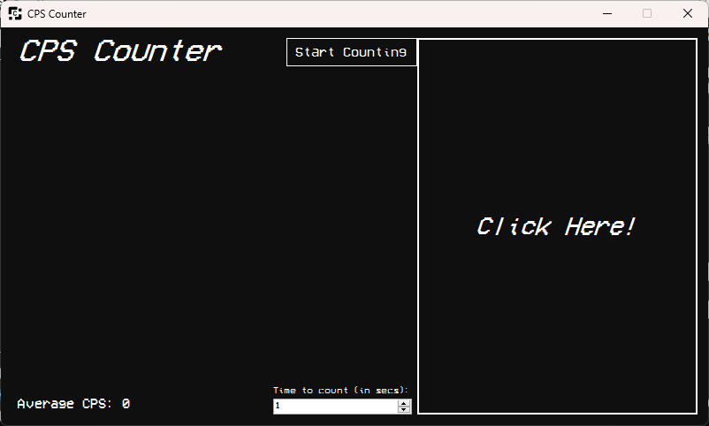

The window is very simple. Click on the « Start Counting » button, then click on the big button on the right. You can see your average CPS in the bottom-left corner and you can edit the time to count the CPS from 1 second to 50 seconds. This is useful for even more precise approximations.

Settings

The settings are not finished for the moment. Coming soon !

Other Important things

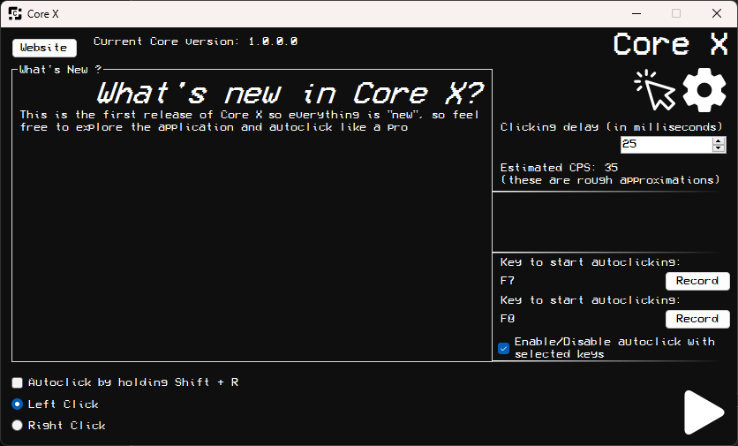In addition to selecting the Key Hold System, you can also choose which click will perform the core. Left Click? Just press Left Click. Press Right click for the opposite !

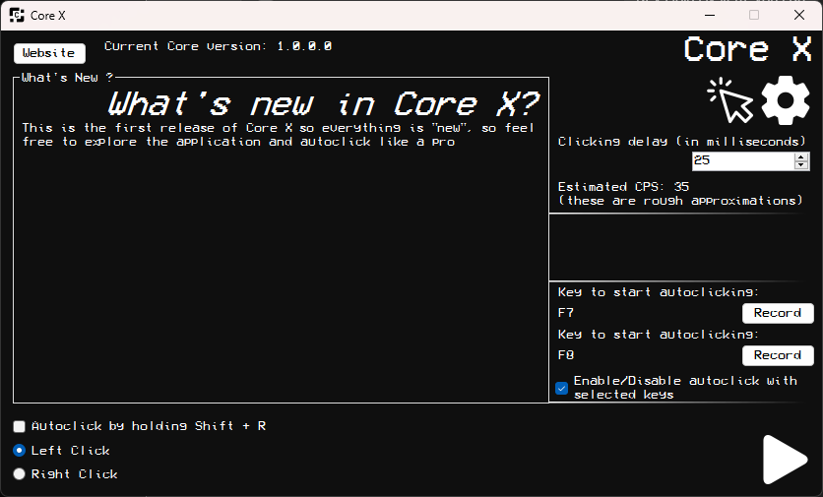

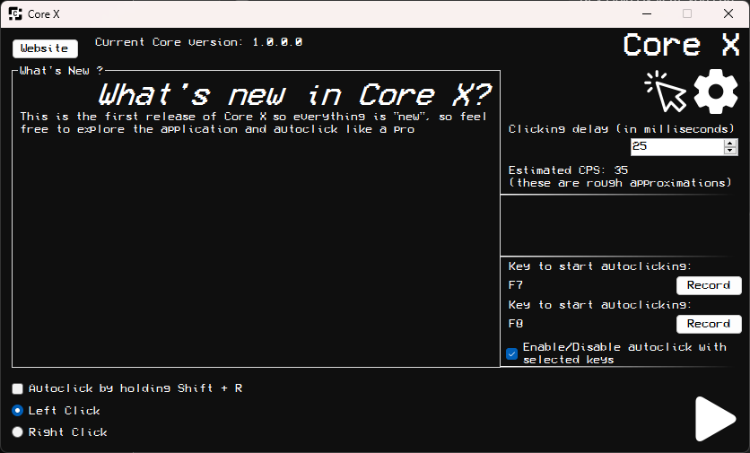In addition to being able to configure the keys to your liking, there's also a button to enable and disable the autoclicker. It's a simple and effective way to enable or disable Core

Although not the most useful, one of these two features lets you see the version you've launched Core on, and the other lets you go to the site with the program's built-in browser.

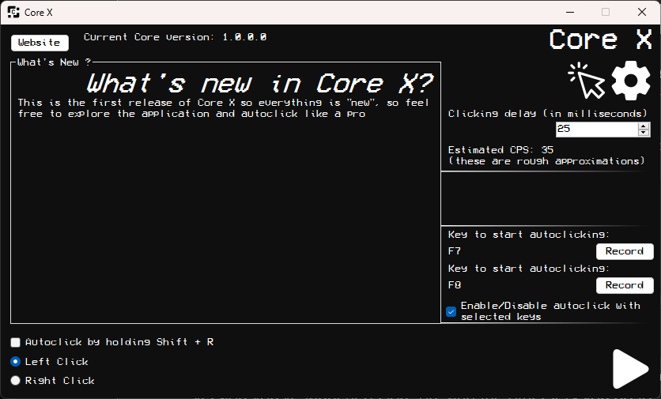This big box lets you know what's new in Core with every new update. So you don't have to go to the documentation for every patch to find out what’s new.

What’s new in Core X ?

|  |  |
| --- | --- |
| 1.0.0.0 | The first release : published to GitHub and published the website. |
|  |  |
|  |  |
|  |  |
|  |  |
|  |  |
|  |  |
|  |  |
|  |  |
|  |  |
|  |  |
|  |  |
|  |  |